Chapter I
INTRODUCTION
The human body is one of the most astonishing creation and natural machine that has been studied and known by human race. The human body is incredibly complex in a way that until today there are abundant mysteries that researches are still trying to uncover specially when it comes to the way the brain perceives events and the human body responds accordingly. Some human reflexes to events are based on human nature or nurture [1]. Humans also have an outstanding ability to control their body the instant they tend to loose stability. There are numerous causes of losing stability, such as a sudden external impact force, a change in the geology of the contact surface of the ground or even a loss in balance [2].
For many years, humans have been trying to artificially redesign the multipart and composite mechanism that constitutes it. The mission is extremely dense, but lead to the design of a machine that looks like a human, behaved and adapts the environment in a way similar to that of humans. However, the current status of these designed robots, is not yet adequate and they are still far from autonomous and self-regulating as expected and desired. Yet, they are used in a diversity of fields. They have been used in the medical field for clinical support, in the educational field as instructors, in the industrial field to perform many tasks instead of humans, in the military field for search and rescue tasks or even combat and many other purposes in numerous fields [3].

Statement of the Problem
A human like structured autonomous robot that is capable of adapting to changes in an environment, takes decisions and performs tasks is called a humanoid robot. This kind of robots is currently under-study and research as scientists and engineers aim to let this robot imitate humans in the way they move, perceive events and also make decisions. They are designed to imitate the human body and its activity when humans have a large number of degrees of freedom and yet can control their movement well even if they were subject to a sudden impact force.
The increased number of degrees of freedom in a Humanoid robot must make it even more difficult to control the movement alone. The case is even taken to a higher level of difficulty if the humanoid is subject to an external impact force which yields to a loss in stability. Humans also have the ability to perceive events and sense their surrounding incredibly due the sense of awareness and consciousness they have and sensory neurons through touch. They can locate themselves in a room without seeing but retrieving information in their memory and act accordingly. They can also stabilize their posture better knowing the cause of turbulence or even the location of an external impact force on them. All these facts and capabilities are ones that the human’s body has whereas robots do not. But the Humanoid should still be designed and integrated to be able to move, perceive events and behave in a way similarly to that of humans;

Hypothesis or Key Questions
Since a humanoid robot is expected and required to behave in a way imitating that of humans’, the robot should be equipped with a design including the minimal requirement for a sense of awareness or consciousness a human has. The ability of a robot to be able to know more about the external effects on it should be improved remarkably special when it comes to external effects that lead to a loss in stability. If the robot perceives it’s surrounding better, only then it will be able to react and control its movement and posture to gain back it stability in a more educated and fed control system in spite of the increasing number of degrees of freedom which makes controlling the robot more difficult.

Proposed Solution
Humanoid robots impact complex problems in control that need to be solved using methods that vary from classical control methods since coordination and balance are continually in demand. In this thesis entitled Humanoid Stability Analysis Based on Impact Location and Intensity, a humanoid robot is going to be modeled in a virtually realistic and robust physics engine where the robot will be tested. The robot will be subject to different types of forces in different locations and intensities and the robot’s response will be observed by monitoring the parameters changing in the sensors of the motors at each joint and link. The results can also be used in a machine learning algorithm that will be trained and then tested to ameliorate and increase the robustness of the stability control algorithm as it will be able to help the robot regain stability in a more educated system. This proposed solution is a good approach to solving the stated problems as it will be reducing or in a way eliminating to use of pressure sensors or any other alternatively used sensors that are used to locate the location, intensity and type of an impact force on the robot.

Specific Objectives and Proposed Time-line
This thesis will mainly target analyzing the stability of a humanoid robot based on the location and the intensity of the impact force. The location of the impact force and its intensity will have to be extracted without the use of sensors.
Frist the humanoid will have to be rendered. The joints properties and parameters will have to be monitored and observed. When the robot is subject to an impact force, a loss in stability is expected with the joints and links moving in a certain way. The change in the robot’s posture will have to be monitored by observing and keeping record of the position of the links and the parameters of the joints. This recorded data is the expected reaction of the robot to a specific kind of force at a known location and with a predefined intensity.
To meet the main objective of this thesis, the specified objectives have to be satisfied in steps of the work after conducting a good research to know more about humanoid robots, the work that have been done, and were studies reached in the field of humanoid stability until now. The entire process will have to be planned in a function of time. The time line in figure 1 displays the expected time need to proceed in two main sectors; the work needed to be done to retrieve results and the documentation of the work in this report. The total time needed for this study to be conducted is expected to be is three quarters of a year. A good amount of time must first be allocated for research followed by the theoretical approach that is expected to be a work that will need a quarter to be done. During this time all the humanoid robot will have to be modeled. When the model is ready the motion analysis for the robot have to be done. Then the robot will have to be tested under disturbances where these impact forces will have to be evaluated with and without sensors to compare the results leaving us with a stability control algorithm which will have to be integrated at a later stage.
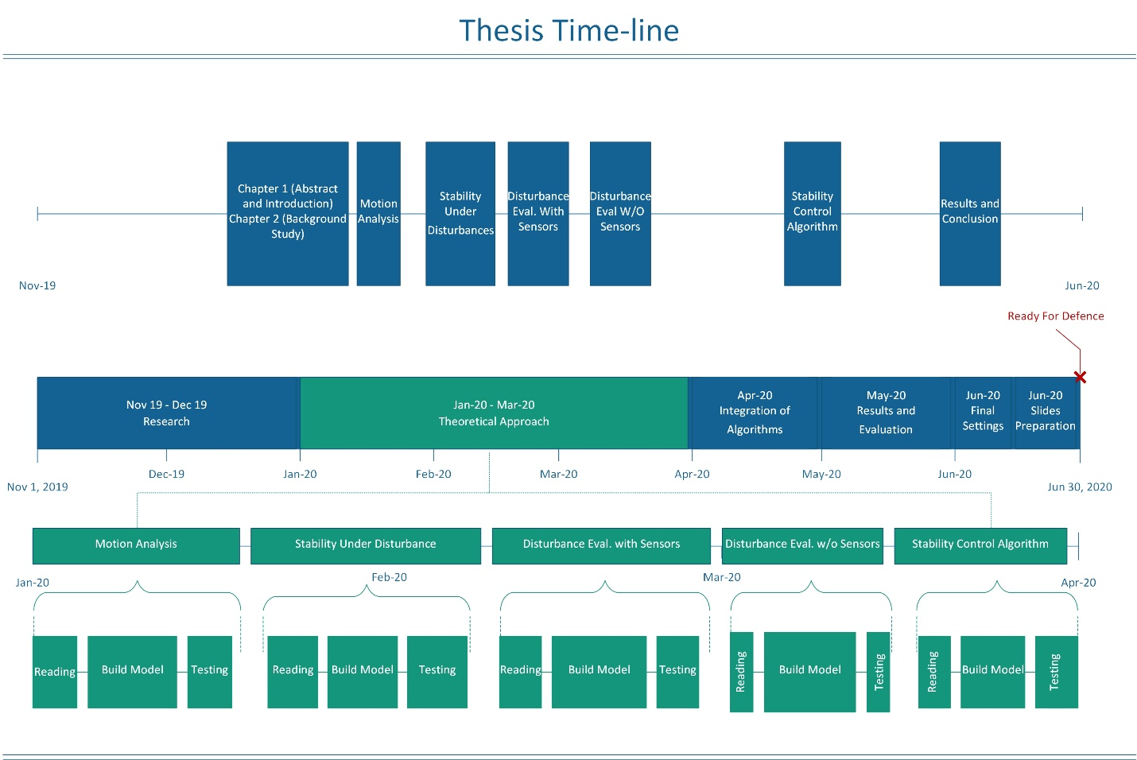
Figure 1. Tentative Time-line

Significance of this Work
Regardless the complexity of the problems, every contributing in this field counts. This thesis will definitely tackle the problem of stability of humanoid in an innovative way based the location and intensity of the impact force which is the main cause of the loss in the robot’s stability. This approach will help in increasing the sense of awareness and consciousness the robot has without having sensors covering the robot’s surface to act like an artificial skin as it has been done by a team from the Technical University of Munich in the research entitled “A Comprehensive Realization of Robot Skin: Sensors, Sensing, Control, and Applications” [4]. As proposed, monitoring the movement and the links and the parameters of the joint of the humanoid when it is subject to an impact force, will help the robot learn more about the impact forces it will be subject to by locating, evaluation, and classifying the impact force. This work will enlighten the humanoid by giving it the ability to regain its stability when lost in a more thoughtful and educated way.

Chapter II
BACKGROUND STUDY
This chapter is written to give a general overview about humanoids, the history behind this technology, its development over the years and where researchers have reached in this field today. The different techniques and methods used to solve the problem humanoid stability will be compared. Moreover, the diverse approaches to increase humanoid robots’ sense of awareness and consciousness will also be discussed. this chapter contains summaries and conclusions that researches came to in this field to solve problems similar to the ones this thesis aims to solve. The research phase in any study is as important as phase in which the results are collected. Taking a closer look at the work of previous studies in the sector of humanoid stabilization helps in taking root in the method used in this thesis to come to an enhancement in the previous stability control algorithms. This chapter is divided into two sections, Literature Review and State of the Art; Literature review papers reflect a broader view about history, background knowledge and development. State of the art papers reflect the present state of scientific or engineering development in the field.

Literature Review

Historical Background

Designed in 1495 is the mechanism of the first humanoid robot by Leonardo da Vinci. Figure 2 depicts the Knight robot as the mechanical skeleton of the robot was covered by a full suit of armor. The links are connected with pulleys and cables to give the robot the ability to sit up, wave arms, move its head along with opening and closing its jaw [5]. This design was them up in action by the Duke of Milan by programming the mechanism as it was designed and also programming it to play drums [6].
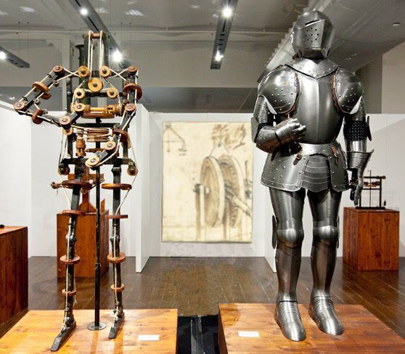
Figure 2. Knight Robot
The first humanoid robot was worked in 1495 by Waseda University in Japan and was called WABOT-1, which represents WAseda RoBOT 1. Despite the fact that not implanted, it could walk, perceive and control some visible items along with recognizing communicated language and voice [7]. Its next variant, WABOT-2, was presented twelve years later with the amazing ability of playing the piano [8].
The development and improvement time of humanoid starts in the nineteenth century when John Brainerd developed the Steam Man in 1865. It was moved by steam-motor and used to pull trucks. In 1885 the Electric Man was worked by Frank Reade Junior which was pretty much an electric form of the Steam Man. Figure 3 depicts the robot Steam Man on the left and its updated version Electric Man on the right. [9]
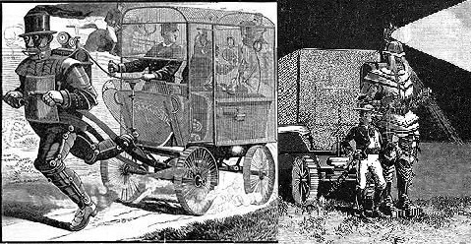
Figure 3. Steam Man and Electric Man
A growing number of humanoid systems and designs appeared during twentieth century. Toward the start of this century the Westinghouse society built a human like robot called ELEKTRO in 1938 shown in figure 4, designed to walk, talk and smoke. Since 1960s to 1990s, various kinds of legged robot began to show up in USA, Russia, France and particularly in Japan. An extraordinary work on a jumping robot was done at Massachusetts Institute of Technology (MIT) in 1980s. The Biped Planar, Spring Flamingo, Spring Turkey, Uniroo and 3D Biped were implemented in MIT having important accomplishments on walking and also running mechanisms in a dynamic and stable steps [9].
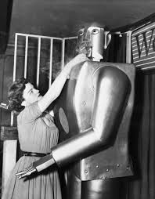
Figure 4. ELECTRO the Smoking Robot
In 1980s, researchers started concentrating stability while walking and improving the posture by enhancing the legs the walking mechanism of humanoid robots. Miura and Shimoyama established a biped robot series BIPER which was unstable while standing but dynamically stable while walking. BIPER-4 robot, depicted in figure 5, had non-motorized articulation at the ankles, large feet and inflexible knees.
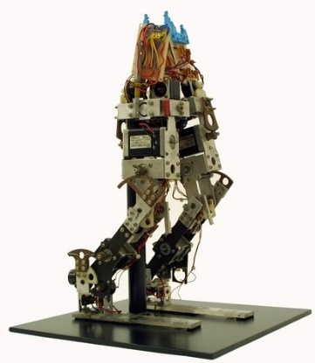
Figure 5. BIPER-4

The development of humanoid robots was remarkably taking place in Japan as the Waseda University was the first to invest in this field by having the first working humanoid designed WABOT-1. A team from Waseda University led by professor Kato also worked on a collection of legged robots during the twentieth century called Waseda Legged (WL). The series of WL robots went from WL-1 which was constructed in 1967 all the way through WL-3 WL-5 constructed in 1972. As the main purpose of these researches was about bipedal locomotion and improving the movement of these bipedal mechanisms, automatic biped walking and the ability to change direction while walking was made possible with WL-5. With improved mechanism of this series was then used at the lower limb of the first working humanoid WABOT-1. Walking forward and backward was implemented by the introduction of rotary servo actuators (RSA) [5].
Next, the artificial muscles made of rubber were introduced which were used as actuators in 1969. They were used as actuators in WPA-1. These powerful pouch-type artificial muscles were used for automatic posture control by also using pressure sensors under the feet in WPA-2. The first three dimensional biped walking was achieved by Kato in the design of WPA-3 in 1971. It was able to walk on a flat surface by keeping its center of gravity in the frontal plane. It was also able to go up and down the stairs or ramps and change its direction while walking. This mechanism was used for WL-5 which was then used as the lower link of the first humanoid WABOT-1 [5].
The study on the humanoid robot WABOT was started in 1970s. WABOT-1 was released in 1973 as the first fun-scale anthropomorphic intelligent robot developed in the world with a limb-control system, a vision and conversion system. This robot was given the ability to communicate with Japanese people and also measure its distance from objects around it using external sensors, artificial ears, eyes and mouth. It is able to walk with its lower limbs and also grab and move objects using tactile-sensors. It was also analyzed that WABOT-1 has the mental ability of an 18-year-old child [10].
WABOT-2, the specialist robot as in was called as it was designed in 1984 to play music on keyboard instruments in a very intelligent manner by reading normal musical notes in a visual sense and play the notes on an electronic organ. WABOT-1 and WABOT-2 are both depicted in figure 6 respectively from left to right [10].

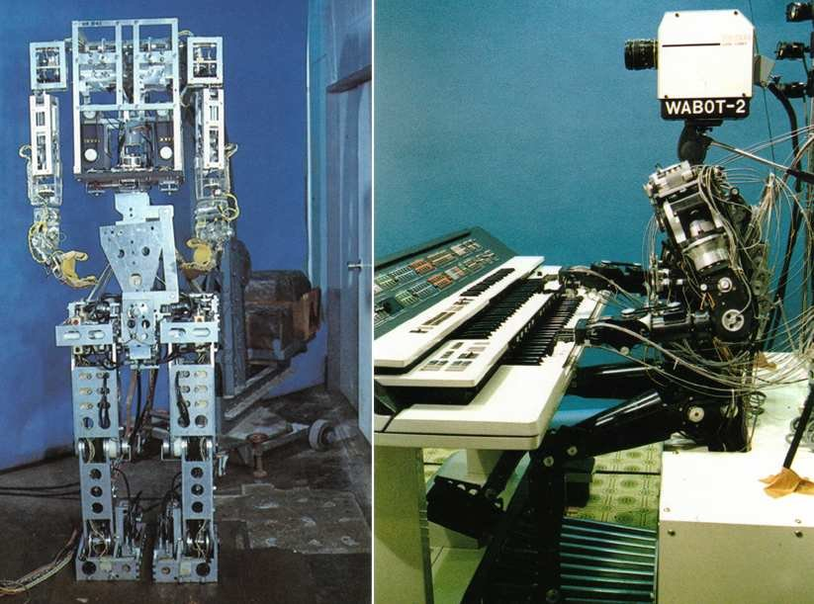
Figure 6. WABOT-1 and WABOT-2
Also in Japan, Honda designed a series of humanoid robots that ran from E0 to E6 starting in 1986, and continued with P1, P2 and P3 until it reached the most intelligent humanoid robot, Advanced Step in Innovation Mobility or ASIMO which is a robot that was given the capability of running. The Honda Humanoid series in depicted in figure 7 [11].
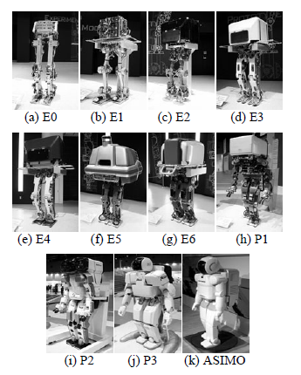
Figure 7. Honda Humanoid Series
First version of ASIMO was 1.2m high with 26 DOF and was mobilized using electric motors. The latest version is established in 2005 having 1.3m high and 34 DOF. This latest humanoid robot was given the capability of Running in straight path as well as circling path as well as circling path which is considered and advancement. Basic specifications of Honda Humanoid series are shown in table 1 [11].
Table 1. Specifications of Honda Humanoid Series
Series | Year | Weight (kg) | Height (cm) | DOF | Walking (Kmh⁻¹) | Running (Kmh⁻¹)
E0 | 1986 | 016.5 | 101.3 | 06 | 5.00 seconds between steps | No
E1 | 1987 | 072.0 | 128.8 | 12 | 0.25
E2 | 1989 | 067.7 | 132.0 | 12 | 1.20
E3 | 1991 | 086.0 | 136.3 | 12 | 3.00
E4 | 1991 | 150.0 | 159.5 | 12 | 4.70
E5 | 1992 | 150.0 | 170.0 | 12 | Slow
E6 | 1993 | 150.0 | 174.3 | 12 | Slow
P1 | 1993 | 175.0 | 191.5 | 30 | Slow
P2 | 1996 | 210.0 | 182.0 | 30 | 2.00
P3 | 1997 | 130.0 | 160.0 | 28 | 2.00
ASIMO | 2000 | 052.0 | 120.0 | 26 | 1.60 | 6.0 (straight) 5.0 (circling)
 | 2005 | 054.0 | 130.0 | 34 | 2.70

Along with the researches carries out in japan, researches in France were conducted simultaneously. First only the role legs and feet was mainly concentrated on in the researches working on bipedal robot in 1993 in Strasbourg University LSIT laboratory in France. The biped robot BIP2000 shown in figure 8, was designed and built by the INRIA Rhone-Alpes and LMS Poitiers. It was 1.8 meters high and having a weight of 105 kg with a locomotive system that helps it walk with gaits that are close that of humans as it had 12 basic mobilities. It was one of the system in which static stability was remarkable to a level that the robot was able to walk at a speed of 0.36 kmh⁻¹ [9].
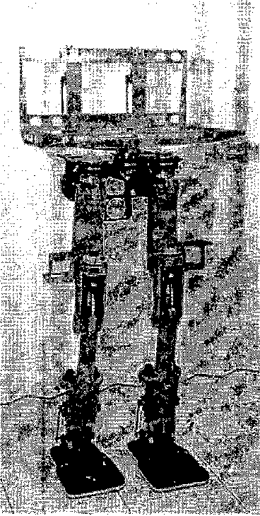
Figure 8. BIP2000 Robot
Expecting to set up walking and running gaits, the RABBIT project was begun in 1998 with CNRS Grenoble, the Frence bipedal robot community. The framework had a couple DOF and each of the gearboxes of the engines was able to deliver a most extreme force of 150 Nm which was fundamental for running gaits. The LIRIS Laboratory at the University of Versailles made a test human biped named ROBIAN in 2004. It had a three-dimensional kinematic architecture with 16 DOF. This 1.30m high robot weighs was 29kg and its foot was designed to be an articulated forefoot along a cross-over pivot moved with a link. The mechanical design of the trunk had three moving weights that help the robot in its maneuverability [9].

Exploration exercises in the field of human mechanical technology are growing quickly. Since the departure of ASIMO robot by Honda and AIBO robot by Sonny, robot fever has broken out in Japan. Thoughtful and fundamental studies about humanoid robots are carried out effectively for the future of humanoid robotic technology. In 2002, a little however generally quick strolling independent humanoid robot was designed having 17 DOF at Technical University Berlin, Germany [12]. An automated humanoid robot was structured in College of Queensland, Australia. The mechanical structure of a human bipedal robot was conveyed out at the National University of Singapore in 2003. The College of Genova, Italy, structured and created two a long time old youngster like humanoid robot called iCub in 2006. In 2000, a progression of KAIST Humanoid Robot (KHR) was created in Korea. KHR-0 which was created in 2001 had 2 legs without chest area. KHR-1 was created on the reason for research about biped strolling which had 21 DOF without any hands and head. The target of KHR-2, 41 DOF humanoid frameworks, was to build up the humanoid framework which could walk on the living-floor with human-like appearance and development. KHR-3 also called HUBO, have more human-like characteristics as it can be seen in figure 9, developments and human-friendly character. HUBO started being known from the year 2005 [5].
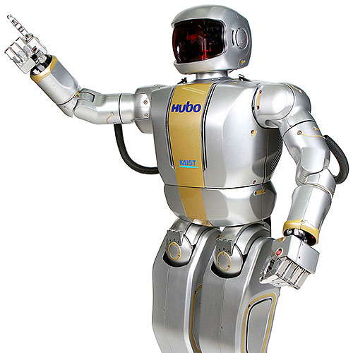
Figure 9. HUBO
The HOAP3 humanoid robot stage supplements the one that was introduced at the LAAS CNRS, Toulouse, France in June, 2006. HOAP3 is shown in figure 10. From 28-31 Walk 2002 ROBODEX2002 (www.robodex.org) was held in Yokohama where a sum of 28 exhibitors, counting 13 organizations, ten colleges, three gatherings were launched with various humanoid robots; ASIMO (Honda), Robovie II, Robovie III (ATR), Guardrobo C3, C4 (Sogo Keibi Hosho), SDR-4X (Sony), Dream Force 01 (Takara), PINO (Tsukuda Unique), QC-SR, Tmsuk04 (Tmsuk Co. Ltd), BN-7, BN-8 (Bandai), HOAP (Jujitsu Automation), Posy (SGI Japan and Flower Robotics), Morph (Japan Science and Innovation Corp. Kitano Symbolic Systems Project), HRP-1S, HRP-2P (Manufacturing Science and Innovation Center), The Shadow (The Shadow Robot Organization, UK). Also colleges were appearing with their humanoid related achievements with YANBO III (Tokyo Institute of Innovation, Hirose Laboratory), SAYA (Science College of Tokyo. Kobayashi Laboratory), KARFE (Nippon Engineering College of Engineering), Mecharobo (Nippon Bunri University, Hirakoso Research facility), Easy Going Daddy-1 (Hosei University, Takashima Laboratory), High Bar Gymnastic Robot, Saxophone-performing Robot, MARI-1, MARI - 2 (Yokohama National University, Kawamura Laboratory), WAMOEBA-2Ri, I SHA, WE-4 (Waseda University, Humanoid Laboratory), Magdan (Kyoto University, Takahashi Laboratory) [5]

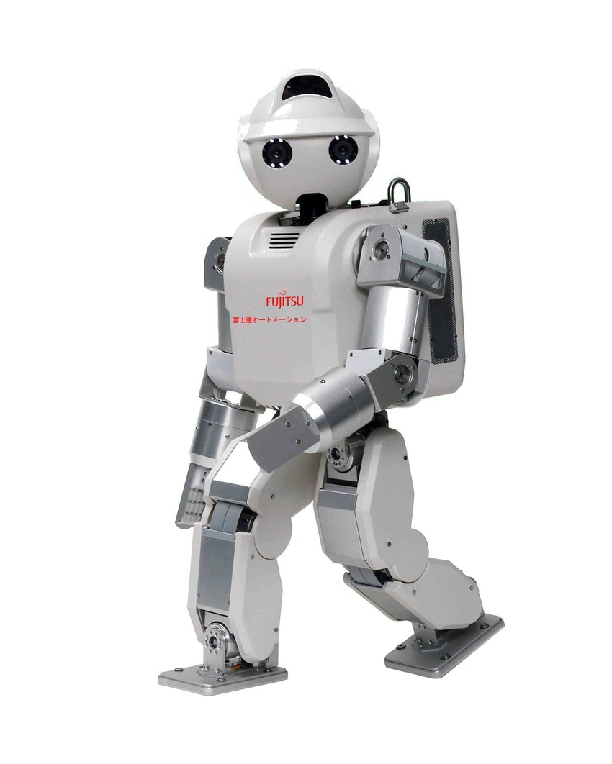
Figure 10. HOAP3

Romeo is a humanoid robot that was modeled and built before the end of 2011. The project is attempted by an alliance of organizations and national labs in France with the expectations to build up a humanoid robotic system that will have the option to help the old and outwardly tested individuals at home. The robot will be a 1.2 to 1.5-meter high bipedal intelligent machine and people could speak with voice or even signs. The framework likewise could assist an individual with getting up if there should arise in case of a fall. The arranging organization in this venture is Aldebaran Robotics, which creates and sells the littler and clever humanoid robot NAO. Both robots NAO and Romeo are shown in figure 11 respectively from left to right [13]. In Malaysia a little size humanoid, Malaysia Boleh, was created with the cooperation between Universiti Teknologi Malaysia (UTM) and Cytron Technologies Sdn. Bhd. [14]. It had the option to adjust itself while walking and standing still on slanted floor. Even turning, moving, push up was accomplished in this robot. IRobo was a human like robot created in International Islamic University Chittagong (IIUC), Bangladesh which was skilled to get objects, wiping floors and perform other basic chores. Siddiky's IRobo, created in 2007, had some uncommon knowledge.
to react to some voice orders [15].

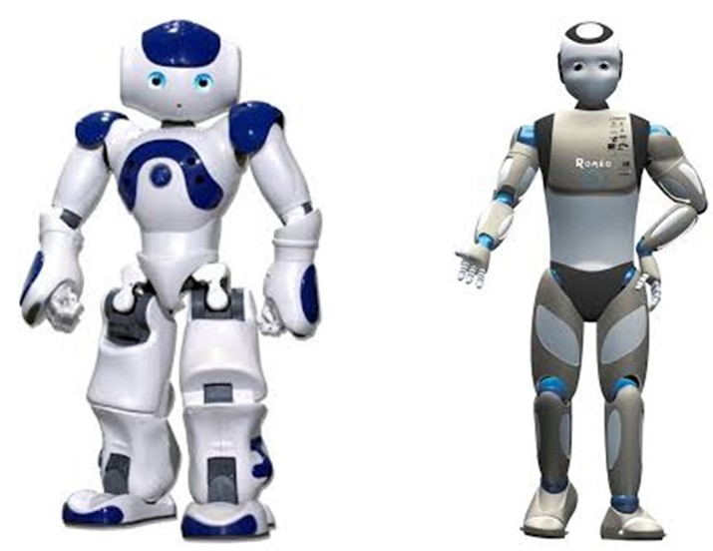
Figure 11. NAO and Romeo

Experimentations on humanoid robots for the use to perform a diversity of tasks were still happening in 2008. With Rollin' Justin a mobile automated system and research stage is introduced that promote the usage of such robots and exhibit modern control calculations. Significant issues of mobile advanced mechanics, for example, adaptable control and systems for utilizing the expanded workspace and repetition in control task can be concentrated in detail. The experimental work covers a diagram of the structure of the moving platform and design of the upper-body which was a table-mounted system at chest area first (Justin) and transform it into (Rollin' Justin), a completely self-supported mobile humanoid robot shown in figure 12 [16].

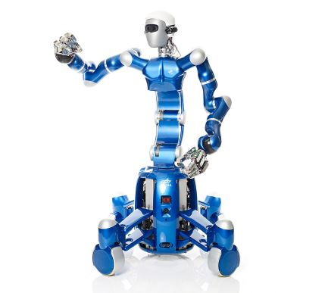
Figure 12. Rollin' Justin

Robonaut 2, considered one of the recent age of the Robonaut astronaut assistants, dispatched to the space station board space shuttle “Discovery” on the STS-133 mission in February 2011. It is the first humanoid robot in space, and despite the fact that its essential activity until further notice is exhibiting to engineers how capable robots act in space, the expectation is that, through updates and headways, it might one day be able to adventure outside the station to assist spacewalkers with troubleshooting or perform scientific work in the station. Work on the first Robonaut started in 1997. The thought was to manufacture a humanoid robot that could help space travelers on undertakings in which another pair of hands would be useful or to wander forward to perform occupations either excessively risky for individuals to or even unnecessary to waste time on. The outcome was R1, a human-like model of a robot that could perform tasks or be mounted on a lot of wheels to investigate far off objections. Through 2006, R1 acted in various investigations in an assortment of research center and field test conditions, demonstrating that the idea of an automated partner was reasonable. The very year, General Motors communicated an enthusiasm for hearing about the task. They had been building up their own robots, and seeing what NASA had achieved, GM proposed collaborating. A Space Act Agreement was marked in 2007 to permit GM and NASA to pool assets and work together on the cutting edge Robonaut.

In February 2010, R2 was uncovered – a quicker, more skillful, more mechanically advanced humanoid robot than had ever been seen previously. Its capability was immediately perceived, and it was taken on the space shuttle Discovery's last mission to the space station. It was the foremost humanoid robot working in space and progress as engineers get to see for the first time how a humanoid robot really acts without gravity [17].
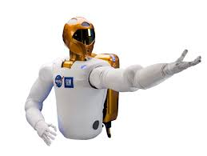
Figure 13. Robonaut 2

In February 2010, R2 was uncovered – a quicker, more skillful, more mechanically advanced humanoid robot than had ever been seen previously. Its capability was immediately perceived, and it was taken on the space shuttle Discovery's last mission to the space station. It was the foremost humanoid robot working in space and progress as engineers get to see for the first time how a humanoid robot really acts without gravity [17].

Manav is two-feet tall and resembles a toy that is large in size. It uses 21 sensors, two cameras in its eye attachments and two microphones on either side of its head. Manav is India's first 3D printed humanoid robot. Weighing 2kg, Manav which means man in Sanskrit, has a built in vision and sound handling capacity, permitting it to talk and act like a human. “The lower price point will allow more colleges to avail of it, and this plays in very well with the government’s recent ‘Make in India’ campaign. Besides, parts can be easily replaced at a reasonable cost since they are available in India," said Vaish. The robot has two degrees of freedom in its head and neck which help it move its head both, sideways and also longitudinally. Moreover, grabbers are being added to the robot’s arms so that it can lift objects [18].

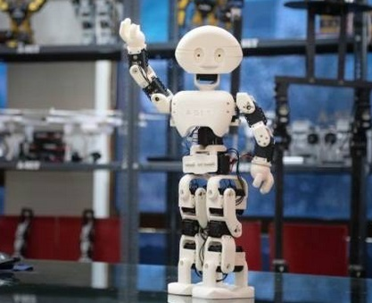
Figure 14. Manav

The world’s most dynamic humanoid robot is Atlas by Boston Dynamics. It is in its examination stage, intended to stretch the boundaries of full-body mobility. The parts of its skeleton are 3D printed aircraft-grade aluminum and titanium. It is made of two arms, two legs, a head and two hands which were designed by two different contractors; one by Sandia National Labs and the other by iRobot. When assembled, the humanoid is 1.5 m high and weighs 80 kg. The robot has an on-board real-time computer. Atlas’s high level control enables the robot to demonstrate human-level agility when it comes to its power and balancing. It is made of the world’s most compact hydraulic system. The robot’s mobility impressive due to the high power delivered to all 28 hydraulic joints. The motors, valves and the hydraulic power unit are assembled and configured to ensure that a high power is delivered to the joints of the humanoid. This incredibly dynamic robot is controlled by an advanced control system leading the system to perceive its environment via LIDAR and stereo vision technology, plan and move accordingly with a speed on 1.5 m/s. Atlas was disclosed on July 11 2013 by the Defense Advanced Research Projects Agency (DARPA) to help in emergency situations being able to be operated in dangerous areas. Atlas is trained to be able to avoid obstacles, walk on different terrains, manipulate static and dynamic objects. It can also perform backflips, jump over log lying on the grass and jump over objects [19].
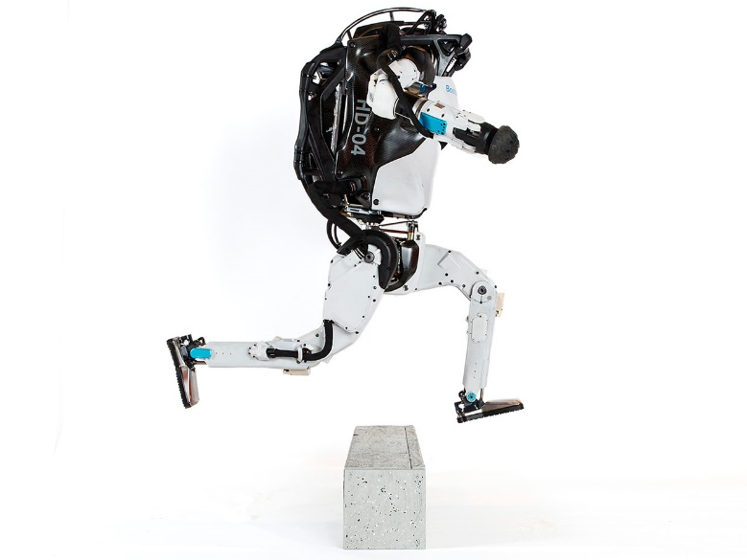
Figure 15. Altas

State of the Art
Since a humanoid robot is expected and required to behave in a way imitating that of humans’, the robot should be equipped with a design including the minimal requirement for a sense of awareness or consciousness a human has.

